Amazon A2I (Amazon Augmented AI)
Human-in-the-Loop Machine Learning

What is Amazon A2I?
A managed AWS service that enables Human-in-the-Loop (HITL) machine learning.
It automatically routes low-confidence ML predictions to human reviewers for validation.

Key Advantages
- Improved accuracy via human oversight
- Ensures compliance in critical applications
- Reduces effort in building review systems
- Flexible workforce options

Workforce Options
- Private Team → Your employees , Internal teams
- Third-Party Vendors
- Amazon Mechanical Turk (MTurk) → Crowd workers

Concept
Human-in-the-loop ML:
- ML makes prediction
- Confidence is checked
- If low → Human verifies

Architecture & Workflow
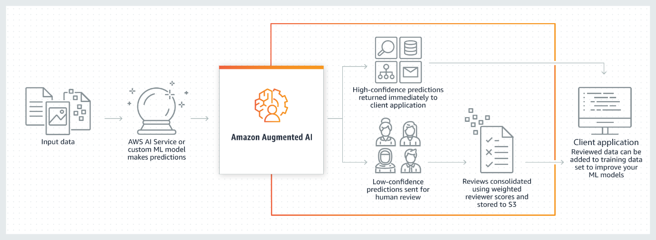

Step-by-Step Flow:
- ML Model Prediction
Model generates output (Textract / Rekognition / SageMaker)
- A2I Evaluation
Checks confidence threshold & business rules
- Human Review
Low-confidence tasks sent to humans via UI
- Result Consolidation
Reviewed output stored & returned

Integrated AWS Services
- Amazon Textract
- Amazon Rekognition
- Amazon SageMaker
- Amazon Comprehend
- Amazon Transcribe
- Amazon Translate

Use Cases
Document Processing
- Verify PII redaction
- Extract key-value data from tax/mortgage docs
Content Moderation
- Review harmful/explicit content
Healthcare & Finance
- Validate diagnoses or loan decisions
Text Extraction
- Validate OCR outputs

Amazon Transcribe
Automated Speech Recognition (ASR)

🔹 What is Amazon Transcribe?
A fully managed ASR service that converts speech into text using deep learning.
- Converts speech → text using deep learning
- Works on audio & video
- No manual typing required

Key Features
- Real-Time Streaming → Live captions
- Batch Transcription → Process recorded audio
- Speaker Diarization → Identify speakers
- Custom Vocabulary → Domain-specific words
- Content Redaction → Hide sensitive data
- Call Analytics → Sentiment & issue detection

Architecture
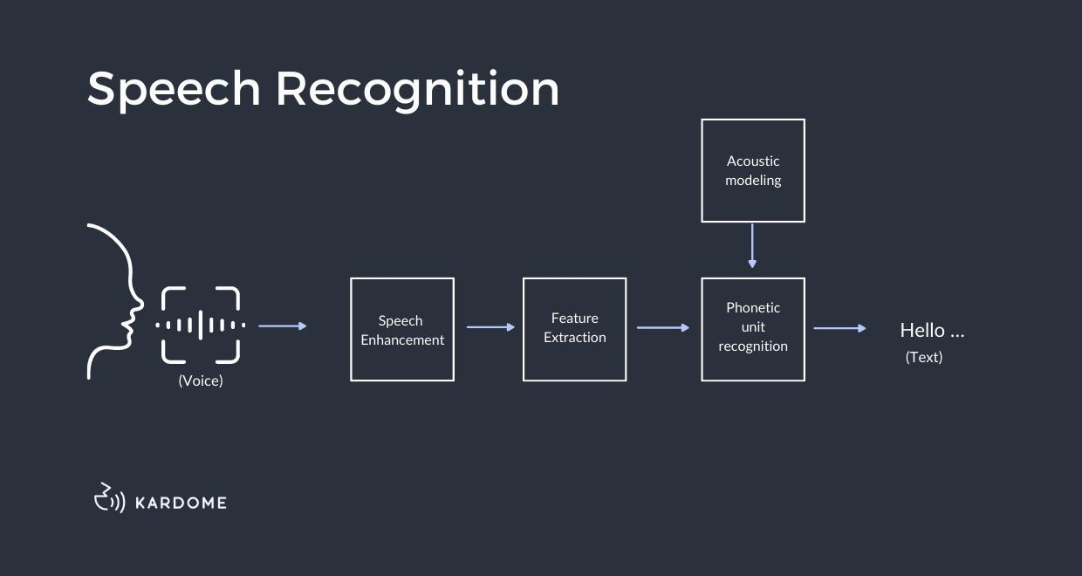
- Audio Input (MP3/WAV/MP4) → stored in S3
- Processing → Detect language, speakers
- ASR Engine →
  - Audio → phonemes → words → text
- Output → JSON / TXT / SRT / VTT

Industry Use Cases
Call Centers
- Analyze customer calls
- Sentiment & quality monitoring
Healthcare
- Clinical documentation
- Voice-based records
Education
- Lecture transcription
- Accessibility support
Media & Entertainment
- Subtitles & captions
Integration
- Amazon Comprehend → Sentiment analysis
- Amazon Translate → Multilingual output

Amazon Kendra
Intelligent Enterprise Search powered by ML & NLP

What is Amazon Kendra?
An AI-powered enterprise search service using NLP + Machine Learning to provide accurate answers.
It understands meaning, context, and intent, not just keywords.

Key Differentiator
Instead of showing links, Kendra gives direct answers.
Example:
“How many leaves are allowed?”
Returns exact HR policy answer- Employees get 20 paid leaves per year

Kendra vs Traditional Search
Feature | Traditional | Kendra
Search Type | Keyword-based | AI/NLP-based
Accuracy | Low | High
Context Awareness | No | Yes
Learning | Static | Dynamic
Answer Type | Links | Direct answers

Architecture (Step-by-Step)
- Data Ingestion
Connect S3, SharePoint, Salesforce
- Document Parsing
Extract text, tables, metadata
- NLP Processing
Understand intent & context
- Index Creation
Build ML-powered searchable index
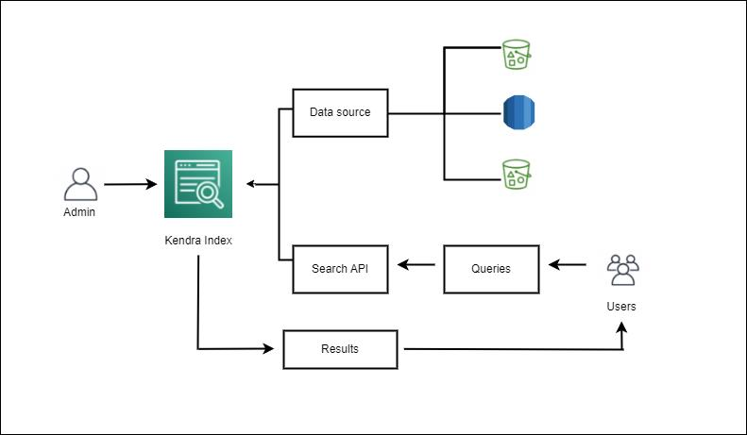
Query Flow
- User Query
- Query Understanding
- Search & Match
- ML Ranking
- Direct Answer

Key Features
- Natural Language Search
- 200+ Data Connectors
- FAQ Matching
- Access Control (IAM-based)
- ML Relevance Ranking
- Custom Tuning

Use Cases
Enterprise Search → HR, IT, policy search , Internal knowledge base
Customer Support → Chatbots, self-service portals
Knowledge Management → Centralized knowledge base
AI Applications → SaaS Q&A systems, AI Chatbots, Integration with bots

SUMMARY — When to Use Which Service?

Amazon A2I
Use when:
- ML outputs need validation
- Working in regulated industries
- Content moderation required
- Document accuracy is critical

Amazon Transcribe
Use when:
- Transcribing meetings/calls
- Generating subtitles
- Analyzing conversations
- Building voice-based systems

Amazon Kendra
Use when:
- Fast document search is needed
- Replacing keyword search
- Building self-service portals
- Creating AI-powered search apps

